**DAILY ONLINE ACTIVITIES SUMMARY**

|  |  |  |  |  |  |  |  |  |
| --- | --- | --- | --- | --- | --- | --- | --- | --- |
| **Date:** | **07/07/2020** | | | | | **Name:** | **NAIPUNYA VINOD NAIK** | |
| **Sem & Sec** | **IV SEM & A SECTION** | | | | | **USN:** | **4AL18CS050** | |
| **Online Test Summary** | | | | | | | | |
| **Subject** | | **NO INTERNALS CONDUCTED** | | | | | | |
| **Max. Marks** | | **--------------** | | **Score** | | | **-------------------** | |
| **Certification Course Summary** | | | | | | | | |
| **Course** | 1. **C++ PROGRAMMING STEP BY STEP FROM BEGINNER TO ULTIMATE LEVEL** | | | | | | | |
| **Certificate Provider** | | | **UDEMY** | | **Duration** | | | **11 HRS** |
| **Coding Challenges** | | | | | | | | |
| **Problem Statement: NO PROBLEM STATEMENT** | | | | | | | | |
| **Status: EXECUTED** | | | | | | | | |
| **Uploaded the report in Github** | | | | | **YES** | | | |
| **If yes Repository name** | | | | | <https://github.com/naipunya-naik/daily-progress-report> | | | |
| **Uploaded the report in slack** | | | | | **YES** | | | |

Online Test Details: (Attach the snapshot and briefly write the report for the same).

NO INTERNALS CONDUCTED

Certification Course Details: (Attach the snapshot and briefly write the report for the same).

CERTIFICATION COURSE NAME:- C++ PROGRAMMING STEP BY STEP FROM BEGINNER TO ULTIMATE LEVEL

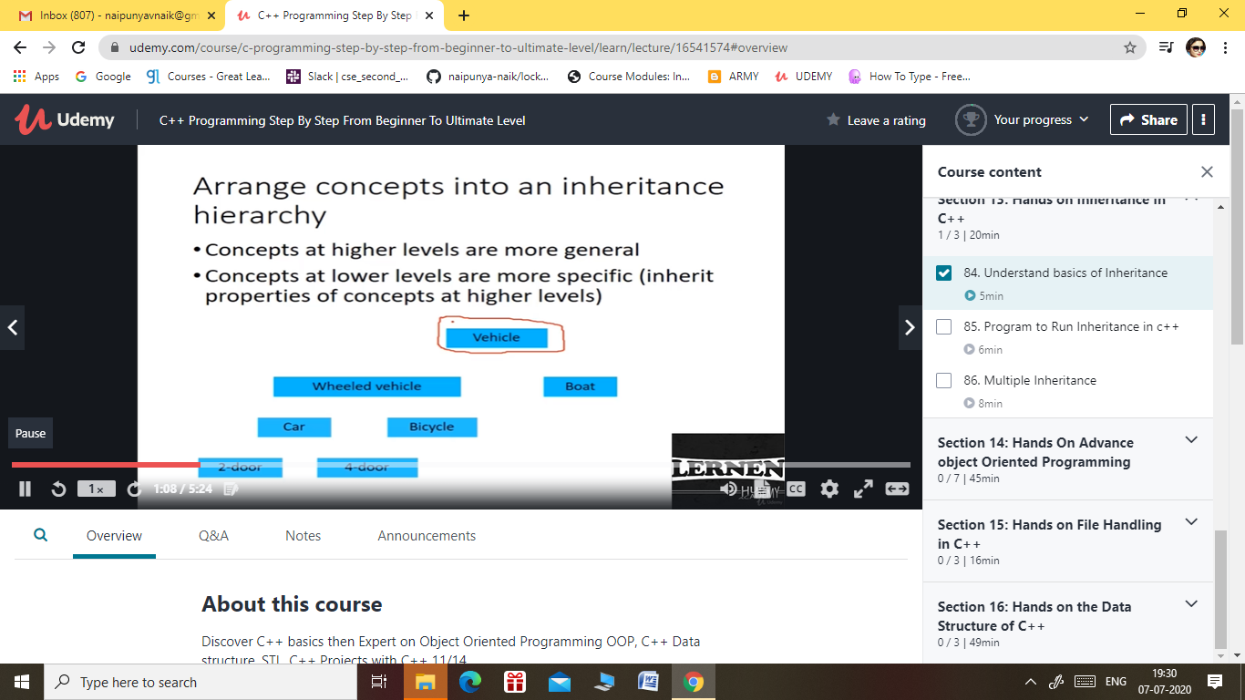

TOPICS COVERED ON

**Section 1: Introduction**

**Section 2: Setting Up Environment  
and Code, Compile and Execute in …**

**Section 3: Hands on C++ Basics ,  
variables, data types, Modifier Typ…**

**Section 4: Hands on C++ Operators  
and its type**

**Section 5: Hands on Control Flow ,  
Statement Loops and If Else statem…**

**Section 6: Hands on Functions in  
C++**

**Section 7: Hands on Arrays and its  
type in C++**

**Section 8: Hands on Pointer in C++**

**Section 9: Hands on String in C++**

**Section 10: Hands on Dynamic  
Memory in C++**

**Section 11: Hands on Beyond the  
Basics on C++**

Coding Challenges Details: (Attach the snapshot and briefly write the report for the same).

**NO PROBLEM STATEMENT**